Introduction to Algorithms Assignment Report

Introduction

This is the Report for the Introduction to Algorithms Assignment given to do over Easter Break.

Submitted with this Report Document is the .c file with the program called “LogLinesProject.c”.

This report will talk about:

- An outline of the brief given (Brief Description of Required Tasks).
- My design for each Task.
- My test plan for each Task.
- Pseudocode, Code and Flowchart.
- Snipped of Output.

Outline of Brief Given

There were 4 Tasks that needed to be completed.

Task 1

- Each Line log is to be ordered by Product ID then Issue Code lastly Date & Time.
- This is to be done in a Time Complexity (Big O) of : O(n Log n) or better.

Task 2

- Product can now be manufactured in any line.
- Output should be in a single list ordered by Line ID then Product ID and lastly Issue Code.
- This is to be done in a Time Complexity (Big O) of : O(n) or better.

Task 3

- A way to search the earliest occurrence of an Issue Code for a given Product ID.
- This is to be done in a Time Complexity (Big O) of : O(n) or better.

Task 4

- Output should show all the Issues for a Product ID across all lines.
- This is to be done in a Time Complexity (Big O) of : O(n) or better.

Design and Test Plan

General Overview

Structure Used:

- These are the Struct Definitions used to accomplish all Tasks.

#include <stdio.h>
#include <stdlib.h>

//Struct definitions
struct LineCode {
int numeric;
};

struct BatchCode {
int numeric;
};

struct BatchDateTime {
int dayOfMonth;
int hourOfDay;
int minuteOfHour;
};

struct ProductId {
int numeric;
};

struct Issue {
int code;
char description[100];
};

struct Resolution {
int code;
char description[100];
};

struct ReportingEmployee {
int id;
};

//Struct to hold all the data for a product line
typedef struct product_line {
struct LineCode lineCode;
struct BatchCode batchCode;
struct BatchDateTime batchDateTime;
struct ProductId productId;
struct Issue issue;
struct Resolution resolution;
struct ReportingEmployee reportingEmployee;
} product_line;

- These are all the Function Prototypes used to accomplish all Tasks.

//Function prototypes
void insert_test_data(struct product_line line_array[]);
void merge_sort(struct product_line line_array[], int left, int right);
void merge(struct product_line line_array[], int left, int middle, int right);
void report_on_productID(product_line* line_array, int lines, int log_size);
int compare_lines(product_line* line1, product_line* line2);
void print_all(product_line line_array[], int left, int right);
void search_issue_code(product_line* line_array);
void count_issues_for_all_products(product_line* line_array, int array_size);

- Lastly, it’s the Main function which calls to each of the main four tasks functions.
- This is all the beginning of the code to be used to complete Tasks 1 through 4.

int main() {
//Array of product_line structs
struct product_line line_array[44];

//Insert test data into the array
insert_test_data(line_array);

//Sort the array using merge sort
printf("\n---TASK 1) Report based on product ID---\n");
report_on_productID(line_array, 1, 11);

//Sort the array using merge sort
printf("\n---TASK 2) Issues Report---\n");
print_all(line_array, 0, 43);

//Search for a specific Product ID and list it's earliest Issue code in the array
printf("\n---TASK 3) Search for Issue Code---\n\n");
search_issue_code(line_array);

//List all the issue codes, the product ID related and their descriptions
printf("\n---TASK 4) List Issue Codes---\n");
count_issues_for_all_products(line_array, 44);

return 0;
}

- This is all the test data used to test all the Tasks.

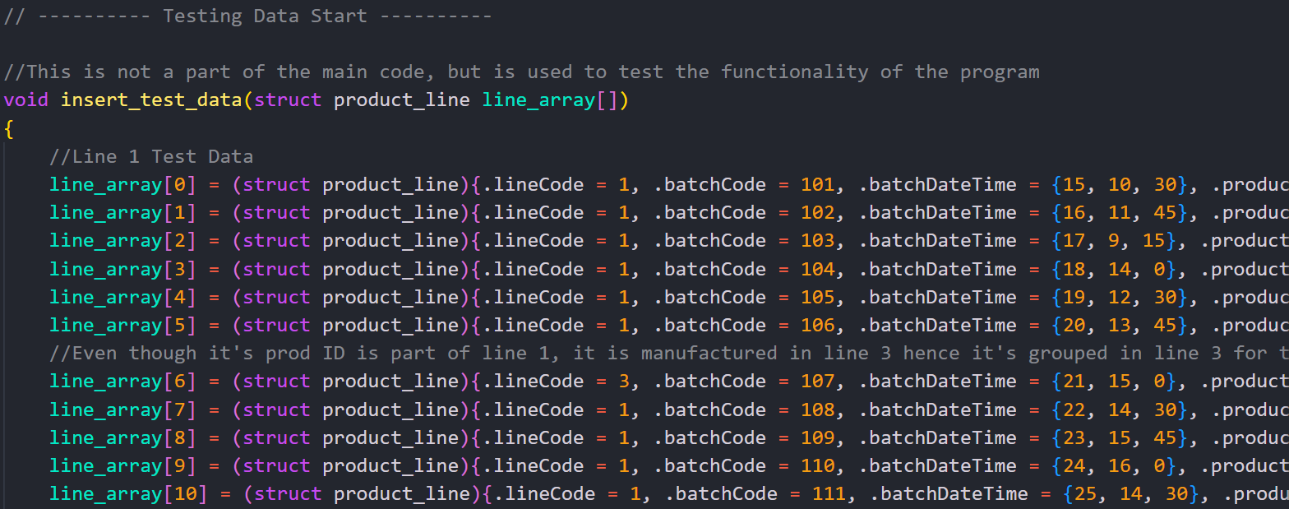

- Due to it being too long I have not copied all the Test Data, however:

line_array[0] = (struct product_line){.lineCode = 1, .batchCode = 101, .batchDateTime = {15, 10, 30}, .productId = 105, .issue = {404, "Leakage detected"}, .resolution = {200, "Leak sealed"}, .reportingEmployee = 501};

- This would be how each line looks, 4 Lines for the 4 different Production Lines and 11 Issues each Line as the brief requires to use more than 10 test data, culminating to a total of 44 Test Data.

Task 1

- Task one is the longest task of them all, as to accomplish what is required a Merge Sort needed to be done.
- But not just a normal merge sort, it needed to be sorted in a specific way AND have to be done in a Time Complexity of O(n Log n).
- Below is the pseudocode created for this task.

Pseudocode

Begin function report_on_productID(line_array, lines, log_size)
merge_sort(line_array, 0, 4 * log_size - 1);

print_logs(line_array, log_size, 1);
print_logs(line_array, log_size, 2);
print_logs(line_array, log_size, 3);
print_logs(line_array, log_size, 4);
End Function

Begin function print_logs(line_array, log_size, line_number)
print("---Logs for Line " + line_number + "---");
Begin for (i = (line_number - 1) * log_size; i < line_number * log_size; i++)
log = line_array[i];
print("Product ID: " + log.productId + ", Issue Code: " + log.issue.code + ", Date & Time: " + log.batchDateTime.dayOfMonth + "-" + log.batchDateTime.hourOfDay + ":" + log.batchDateTime.minuteOfHour);
End for
End Function

Begin function merge_sort(line_array, left, right)
Begin if (left < right)
middle = left + (right - left) / 2;
merge_sort(line_array, left, middle);
merge_sort(line_array, middle + 1, right);
merge(line_array, left, middle, right);
End if
End Function

Begin function merge(line_array, left, middle, right)
initialize n1 as middle - left + 1;
initialize n2 as right - middle;

initialize L as new Array(n1);
initialize R as new Array(n2);

Begin for (i = 0; i < n1; i++)
L[i] = line_array[left + i];
End for
Begin for (j = 0; j < n2; j++)
R[j] = line_array[middle + 1 + j];
End for

initialize i as 0;
initialize j as 0;
initialize k as left;

Begin while (i < n1 && j < n2)
Begin if (call function compare_lines(L[i], R[j]) <= 0)
line_array[k] = L[i];
i++;
End if
Begin else
line_array[k] = R[j];
j++;
End else
k++;
End while

Begin while (i < n1)
line_array[k] = L[i];
i++;
k++;
End while

Begin while (j < n2)
line_array[k] = R[j];
j++;
k++;
End while
End Function

Begin function compare_lines(line1, line2)
Compare Line Code
if it's the same, compare Product ID
if it's the same, compare Issue Code
if it's the same, compare Date & Time
return 0;
End Function

- The function “report_on_productID” is one of the four mayor functions that is called by the Main function, all this function does is call the “merge_sort” function to merge and sort all the array and call the “print_logs” function which prints all the logs merged and sorted per Line.
- For this I created a separate function “compare_lines”.
- Due to Task 2, I sorted the array by: Line ID then Product ID then Issue Code and lastly Date & Time.
- Lastly, I called the function for sorting inside the “merge” function.
- By creating a merge sort function that sorts the log lines in a specific way it allows for this task to be completed in a Time Complexity of O(n Log n), thus completing Task 1.

Code:

// ---------- Task 1 Start ----------

/*
Function to print the merged array
Big O Notation: O(n log n)
The merge sort algorithm has a time complexity of O(n log n) for the average and worst case scenarios
*/
void report_on_productID(product_line* line_array, int lines, int log_size) {

//Merge and Sort the array
merge_sort(line_array, 0, 4 * log_size - 1);

//Print the logs for the first line
printf("\n---Logs for Line 1---\n");
for (int i = 0; i < log_size; i++) {
//Create a temporary instance of the product_line struct for ease of printing
product_line log = line_array[i];
printf("Product ID: %d, Issue Code: %d, Date & Time: %02d-%02d:%02d\n", log.productId, log.issue.code,
log.batchDateTime.dayOfMonth, log.batchDateTime.hourOfDay, log.batchDateTime.minuteOfHour);
}

//Print the logs for the second line
printf("\n---Logs for Line 2---\n");
for (int i = log_size; i < 2 * log_size; i++) {
//Create a temporary instance of the product_line struct for ease of printing
product_line log = line_array[i];
printf("Product ID: %d, Issue Code: %d, Date & Time: %02d-%02d:%02d\n", log.productId, log.issue.code,
log.batchDateTime.dayOfMonth, log.batchDateTime.hourOfDay, log.batchDateTime.minuteOfHour);
}

//Print the logs for the third line
printf("\n---Logs for Line 3---\n");
for (int i = 2 * log_size; i < 3 * log_size; i++) {
//Create a temporary instance of the product_line struct for ease of printing
product_line log = line_array[i];
printf("Product ID: %d, Issue Code: %d, Date & Time: %02d-%02d:%02d\n", log.productId, log.issue.code,
log.batchDateTime.dayOfMonth, log.batchDateTime.hourOfDay, log.batchDateTime.minuteOfHour);
}

//Print the logs for the fourth line
printf("\n---Logs for Line 4---\n");
for (int i = 3 * log_size; i < 4 * log_size; i++) {
//Create a temporary instance of the product_line struct for ease of printing
product_line log = line_array[i];
printf("Product ID: %d, Issue Code: %d, Date & Time: %02d-%02d:%02d\n", log.productId, log.issue.code,
log.batchDateTime.dayOfMonth, log.batchDateTime.hourOfDay, log.batchDateTime.minuteOfHour);
}
}

//Function to merge two sub-arrays of line_array[]
void merge(product_line line_array[], int left, int middle, int right) {
int i, j, k;
int n1 = middle - left + 1;
int n2 = right - middle;

//Create temporary arrays
struct product_line L[n1], R[n2];

//Copy data to temporary arrays L[] and R[]
for (i = 0; i < n1; i++) {
L[i] = line_array[left + i];
}
for (j = 0; j < n2; j++) {
R[j] = line_array[middle + 1 + j];
}

//Merge the temporary arrays back into line_array[]
i = 0;
j = 0;
k = left;
//Sort using the compare_lines function
while (i < n1 && j < n2) {
if (compare_lines(&L[i], &R[j]) <= 0) {
line_array[k] = L[i];
i++;
} else {
line_array[k] = R[j];
j++;
}
k++;
}

//Copy the remaining elements of L[], if there are any
while (i < n1) {
line_array[k] = L[i];
i++;
k++;
}

//Copy the remaining elements of R[], if there are any
while (j < n2) {
line_array[k] = R[j];
j++;
k++;
}
}

//Function to merge sort the array of product_line structs
void merge_sort(product_line line_array[], int left, int right) {
if (left < right) {
int middle = left + (right - left) / 2;

//Sort the first and second halves
merge_sort(line_array, left, middle);
merge_sort(line_array, middle + 1, right);

//Merge the sorted halves
merge(line_array, left, middle, right);
}
}

/*
Function to compare two product_line structs
By comparing the product ID, issue code, and date
*/
int compare_lines(product_line* line1, product_line* line2)
{
//Compare by line code, if they're not equal, return the difference
if (line1->lineCode.numeric != line2->lineCode.numeric) return line1->lineCode.numeric - line2->lineCode.numeric;

//If line is equal, compare by product ID, and return the difference
if (line1->productId.numeric != line2->productId.numeric) return line1->productId.numeric - line2->productId.numeric;

//If product ID is equal, compare by issue code and return the difference
if (line1->issue.code != line2->issue.code) return line1->issue.code - line2->issue.code;

//If issue code and product id are also equal, compare by date and return the difference
if (line1->batchDateTime.dayOfMonth != line2->batchDateTime.dayOfMonth) return line1->batchDateTime.dayOfMonth - line2->batchDateTime.dayOfMonth;

//Both entries are completely equal, return 0
return 0;
}

// ---------- Task 1 End ----------

Snippet of Output:

- This is a snippet of the output of the code.

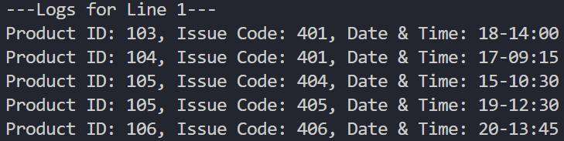

Task 2

- Due to the requirements of Task 2, we can utilize the already merged and sorted log lines from Task one to accomplish this task, all that needs to be done is to print the log lines.
- Since Task 2 is just printing the log lines, it’s Time Complexity is O(n) which is the requirement for this task.

Flowcharts:

- This flowchart is for task 2, where it loops the merged and sorted array and prints the output of each log line.

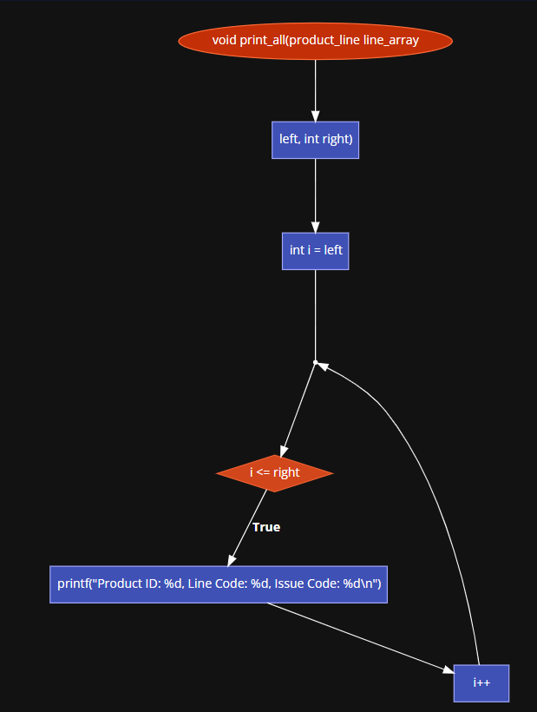

- This is the visualization of how the sorting system being used works.

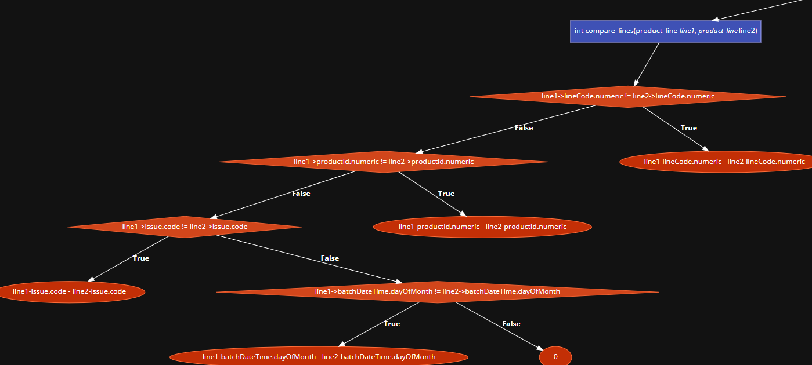

- What it’s doing is comparing the Line Codes first to make sure that every line is printed in order, if the Line Code is the same for two logs, it then compares the Product ID, if they are both the same it then compares the Issue Code, if they are the same it lastly compares the Date & Time to which it then returns the difference as a way to sort it.
- It also returns the difference at any point where the two values are different.

Pseudocode:

- This is pseudocode for Task 2 as previously stated the Time Complexity is O(n) which is accomplished by this code.

Begin function print_all(line_array, left, right)
Begin for i = left to right
printf("Product ID: " ID Variable ", Line Code: " Line Variable ", Issue Code: " Issue Variable ", Date & Time: " Date Variable);
End for
End function

Code:

- The function “print_all” is called in the Main function under task 2.
- This code reads the merged and sorted array from Task 1 and prints it.

void print_all(product_line line_array[], int left, int right) {
for (int i = left; i <= right; i++) {
printf("Product ID: %d, Line Code: %d, Issue Code: %d\n", line_array[i].productId.numeric, line_array[i].lineCode.numeric, line_array[i].issue.code);
}
}

Snippet of Output:

- This is a snippet of the output the code from Task 2 does.

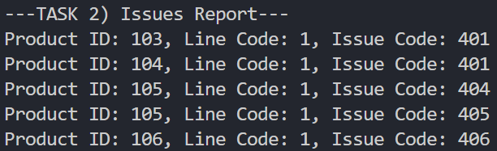

Task 3

- For Task 3 I thought of using another search function, where it searches through the same merged and sorted array from Task 1 and Task 2 to find the earliest occurrence of an Issue Code based on the input of a Product ID.
- So, if someone where to input one of the Product IDs from the Test Data, it will output the earliest occurrence of an Issue Code related to the Product ID, alongside the Line Code and the Date & Time.
- Doing it this way will also accomplish the Time Complexity required of O(n).

Pseudocode:

- This is the Pseudocode for Task 3, as previously stated this code accomplishes the Time Complexity required of O(n).
- It creates two new variables to store the occurrences and the Product ID inputted, then it asks the user to input a Product ID, once inputted it searches through the array for the earliest occurrence of an Issue Code related to the Product ID and then displays it to the user.

Begin function search_issue_code(line_array)
//Variable to store the number of occurrences of the issue code and to store the inputed Product ID
prod, occurrences = 0

//Ask the user for the issue code
printf("Enter the Product ID: ")
read prod

//Iterate through the array and count the number of occurrences of the issue code
Begin for i = 0 TO 44
Begin if line_array[i].productId.numeric = prod THEN
occurrences = occurrences + 1
// Print the first occurrence of the issue code
printf("Issue Code: " Issue Variable ", Line Code: " Line Variable ", Date & Time: " Date Variable)
End if
End for
End function

Code:

- This is the code created to accomplish Task 3.
- The “search_issue_code” function is one of the mayor functions in the program, which is called in the Main function.

void search_issue_code(product_line* line_array) {
//Variable to store the number of occurrences of the issue code
int prod, occurrences = 0;

// Ask the user for the issue code
printf("Enter the Product ID: ");
scanf("%d", &prod);

//Iterate through the array and count the number of occurrences of the issue code
for (int i = 0; i < 44; i++) {
if (line_array[i].productId.numeric == prod) {
occurrences++;
//Print the first occurrence of the issue code
printf("Issue Code: %d, Line Code: %d, Date & Time: %02d-%02d:%02d\n", line_array[i].issue.code, line_array[i].lineCode.numeric, line_array[i].batchDateTime.dayOfMonth, line_array[i].batchDateTime.hourOfDay, line_array[i].batchDateTime.minuteOfHour);
break;
}
}
}

Snippet of Output:

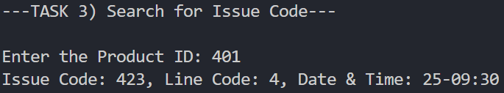

Task 4

- For this task I created another function to print out all the Product IDs and next to them the number of Issues related to set Product ID.
- This was achieved by creating an extra array to store the Product ID and the count of Issues related to it.

Pseudocode:

- This is the pseudocode for the idea on how to complete this task.
- I am using Dynamic Memory Allocation (DMA), to be able to get the size of the array needed to be created.

Begin function countIssuesForAllProducts(lineArray, arraySize)
//Variable to store the maximum product ID in the array
int max_product_id = 0;

//Find the maximum product ID in the array
Begin for (let i = 0; i < arraySize; i++)
// If the current product ID is greater than the max product ID, update the max product ID
Begin if (lineArray[i].productId.numeric > maxProductId)
// Update the max product ID
maxProductId = lineArray[i].productId.numeric;
End if
End for

//Create an array to store the issue counts for each product ID
int *issue_counts = (int*)calloc(max_product_id + 1, sizeof(int));

//Iterate through the array and count the number of issues for each product
Begin for (let i = 0; i < arraySize; i++)
//Increment the issue count for the product ID
issueCounts[lineArray[i].productId.numeric]++;
End for

printf("---Issue Counts for All Products---");

//Print the number of issues for each product
Begin for (let i = 0; i <= maxProductId; i++)
//If the issue count is greater than 0, print the product ID and the issue count
Begin if (issueCounts[i] > 0)
printf("Product ID: " + i + ", Issue Count: " + issueCounts[i]);
End if
End for

//Free the memory allocated for the issueCounts array
free (issueCounts);
End function

Code:

- This is the code created to complete this task.
- It utilizes DMA as previously stated and has a Time Complexity of O(n) since it is only iterating through the array once, this also completes one of the requirements for this task.

void count_issues_for_all_products(product_line* line_array, int array_size) {
int max_product_id = 0;

//Find the maximum product ID in the array
for(int i = 0; i < array_size; i++) {
//If the current product ID is greater than the max product ID, update the max product ID
if(line_array[i].productId.numeric > max_product_id) {
//Update the max product ID
max_product_id = line_array[i].productId.numeric;
}
}

//Create an array to store the number of issues for each product
int *issue_counts = (int*)calloc(max_product_id + 1, sizeof(int));

//Iterate through the array and count the number of issues for each product
for(int i = 0; i < array_size; i++) {
//Increment the issue count for the product ID
issue_counts[line_array[i].productId.numeric]++;
}

printf("\n---Issue Counts for All Products---\n");

//Print the number of issues for each product
for(int i = 0; i <= max_product_id; i++) {
//If the issue count is greater than 0, print the product ID and the issue count
if(issue_counts[i] > 0) {
printf("Product ID: %d, Issue Count: %d\n", i, issue_counts[i]);
}
}

//Free the memory allocated for the issue_counts array
free(issue_counts);
}

Snippet of Output:

- As seen in the snippet of output, it is completing the task required.
- It shows all the Product IDs and the amount of Issues related to it.

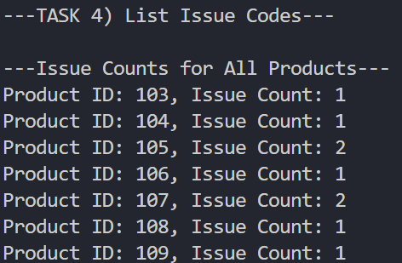

-------------------------------------------------------------------------------------------------------

Report Outcome:

- All Tasks (1 to 4) have been completed with the required Time Complexity and with the required output.
- All Tasks have a Pseudocode to show how an idea of how the final program would work.
- Task 2 has the required Flowchart to show how it works.
- All tasks have the Code created attached to them.
- All tasks have a Snippet of the Output.
- As stated at the beginning of the Report Submitted with this Report Document is the .c file with the program called “LogLinesProject.c”.

